1)website

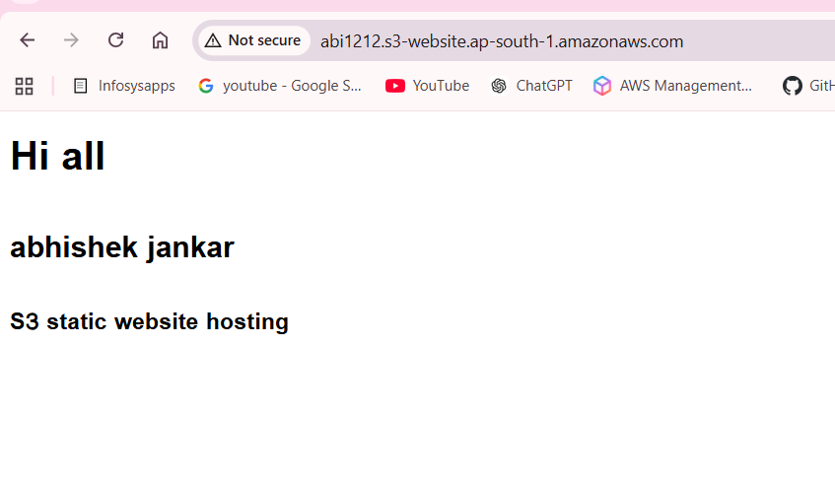

2)Set bucket policy for public read
aws s3api put-bucket-policy --bucket abi1212 --policy '{
"Version":"2012-10-17",
"Statement":[{
"Sid":"PublicReadGetObject",
"Effect":"Allow",
"Principal":"*",
"Action":["s3:GetObject"],
"Resource":["arn:aws:s3:::abi1212/*"]
}]
}'
3) Disable Block Public Access
aws s3api put-public-access-block --bucket rashmi-123456896741 --public-access-block-configuration '{
"BlockPublicAcls": false,
"IgnorePublicAcls": false,
"BlockPublicPolicy": false,
"RestrictPublicBuckets": false
}'

4) Enable static website hosting
aws s3 website s3://abi1212/ --index-document index.html --error-document error.html

5) copy file from git to s3
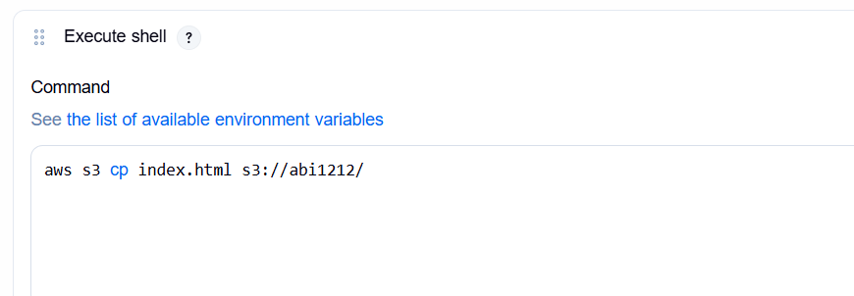

6)git repo add
